Free Early Education For 2 Year Olds
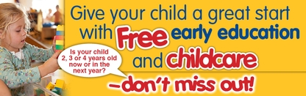

What is free early education and childcare?
All eligible two year olds are able to take a place the term after their birthday
Child’s 2nd birthday is between: | When you can claim:
1 January to 31 March | the beginning of Summer term on or after 1 April
1 April to 31 August | the beginning of Autumn term on or after 1 September
1 September to 31 December | the beginning of Spring term on or after 1 January
The government will fund up to 570 hours of free childcare for each eligible child. This works out as 15 hours a week if your child takes up the childcare during term time, or you could choose to take fewer hours over more weeks in the year.

Is it really free?
Yes. The childcare setting claims the money from the council for these hours so you don’t have to pay for them. It is also possible to combine the free hours with additional paid-for childcare to meet your working pattern or family commitments. Click here (link to prices) for our prices

Is my child eligible for a free place?
If your child is two you are eligible if you are claiming any one of the following:
- Income Support
- Income-based Jobseeker’s Allowance
- Income related Employment and Support Allowance
- Support under part VI of the Immigration and Asylum Act 1999
- The Guaranteed element of State Pension Credit
- Child Tax Credit with earnings from employment below £16,190
- Working Tax Credit with earnings from employment are below £16,190
- Disability Living Allowance (for the child not yourself).
Or if your child:
- is a looked after child
- has left care - a child who has left care through a child arrangement order (formerly known as special guardianship) or an adoption or residence order
- has special educational needs, and/or disabilities – but only if he/she has a current SEN statement or an Education, Health and Care plan or receives Disability Living Allowance.

